

**SAM Portal**

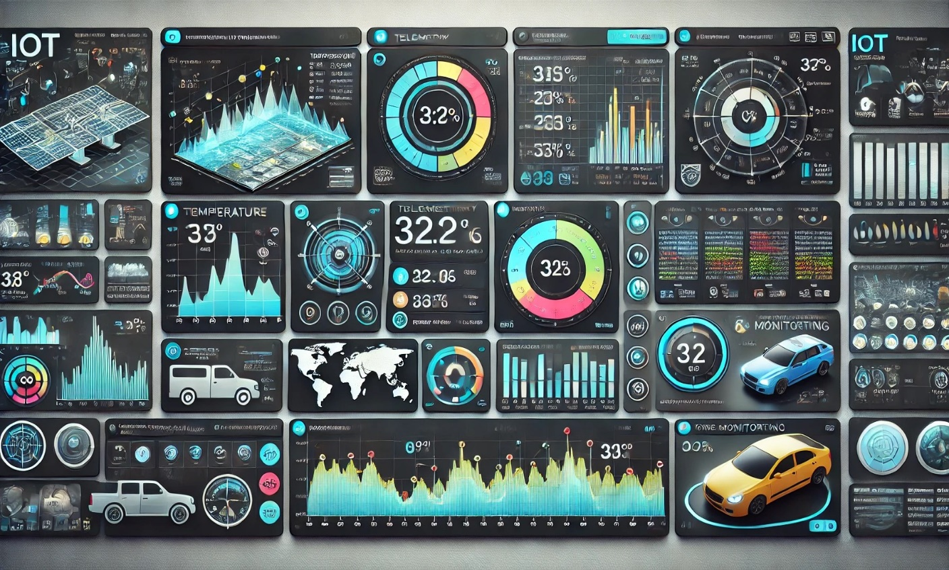

**Revision Records-**

|  |  |  |  |  |  |
| --- | --- | --- | --- | --- | --- |
| **Version** | **Document History** | **Prepared by** | **Reviewed by** | **Approved by** | **Date** |
| 1 | Sam Portal | Rutuja |  |  | 12/12/24 |

Table 1: Revision Records

**Table of Contents-**

1. **SAM Portal-** 5

Objective- 5

1. **System Overview-** 6
2. **Basic Requirements-** 7
3. **Task List-** 8
4. **Screenshots-** 9

1) Dashboard of Device Camera- 9

2) Updated Device from Excel with Parameter- 10

3) Excel File- 11

1. **Logs -** 12

1) Device 1- 12

2) Device 2- 12

3) Device 3- 12

4) Device 4- 13

5) Device 5- 13

6) Device 6- 13

7) Device 7- 14

8) Device 8- 14

9) Device 9- 14

10) Device 10- 15

**List of Figures-**

1. **Figure 1: System Overview 6**
2. **Figure 2 : Dashboard of Device Camera 9**
3. **Figure 3 : Updated device with parameter from excel file 10**
4. **Figure 4 : Excel File 11**

**List of Tables-**

1. **Table 1: Revision Records 2**

# **SAM Portal-**

## **Objective-**

“The objective of the system is to automate the process of transferring data from an Excel sheet

to Things Board, where devices are created with specific keys and values. This data is then

displayed on a dashboard, allowing users to easily monitor and manage devices in a visual

format.”

# 

# **System Overview-**

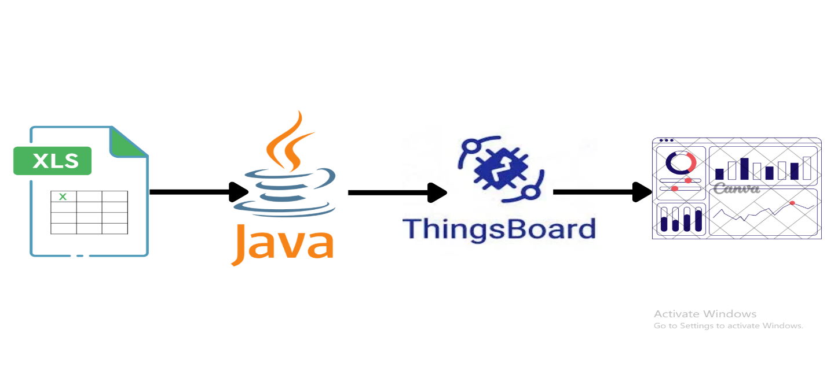

Figure 1: System Overview

# **Basic Requirements-**

**1) Excel Data-**

* Excel file should have the columns for Device name , keys and values.
* Excel File should be at specific location.

**2) Things Board-**

* Log In into Things board using credential.
* Create the devices whose data is going to publish.
* Check the connectivity using MQTT link.

**3) JAVA (Spring Boot)-**

* JAVA version – "21.0.4".
* Dependencies- spring-boot-starter, poi-ooxml, json,

spring-boot-starter-test, org.eclipse.paho.client.mqttv3

* Important packages should imported.
* Add the path of Excel file.
* Add Host name, Access Token, Topics, and port no of each device taken from MQTT link.
* Ensure data should send in the Format of JSON with Time stamp.

**4) Dashboard (ThingsBoard)-**

* Create the Dashboard for each devices in thingsBoard.
* Add particular keys and values for the device using Widget.
* Save the changes and keys and value get displayed in dashboard.

# **Task List-**

**1) Prepare the excel File-**

* Ensure that the file parameters.xlsx exists in the specified location.
* The file must have the following columns: deviceName , key and value.

**2) Spring Boot-**

* **Set Up Device Details**-

Check that DEVICE_TOPICS and ACCESS_TOKENS have the correct device IDs and authentication tokens.

* **Configure MQTT Connection**-

Verify the MQTT broker address and port.

* **Connect to Devices**:

Establish MQTT connections for each device using their unique tokens.

* **Read and Publish Data**-

Read data from the Excel file.

Match each device's data based on its Device ID.

Send the data to the server using MQTT.

* **Repeat Periodically**-

Run the process every 60 seconds.

**3) Device Configuration -**

Each device is associated with-

* A deviceName used in the Excel file and in the java code.
* An Access Token for authentication.
* A Telemetry Topic to publish data.

**4) MQTT Broker Configuration-**

* Broker Address**-** mqtt.thingsboard.cloud
* Broker Port**-** 1883
* Telemetry Topic- v1/devices/me/telemetry
* Protocol**-** MQTT (Message Queuing Telemetry Transport)
* Authentication**-** Access tokens (unique for each device)

# **Screenshots-**

## **1) Dashboard of Device Camera-**

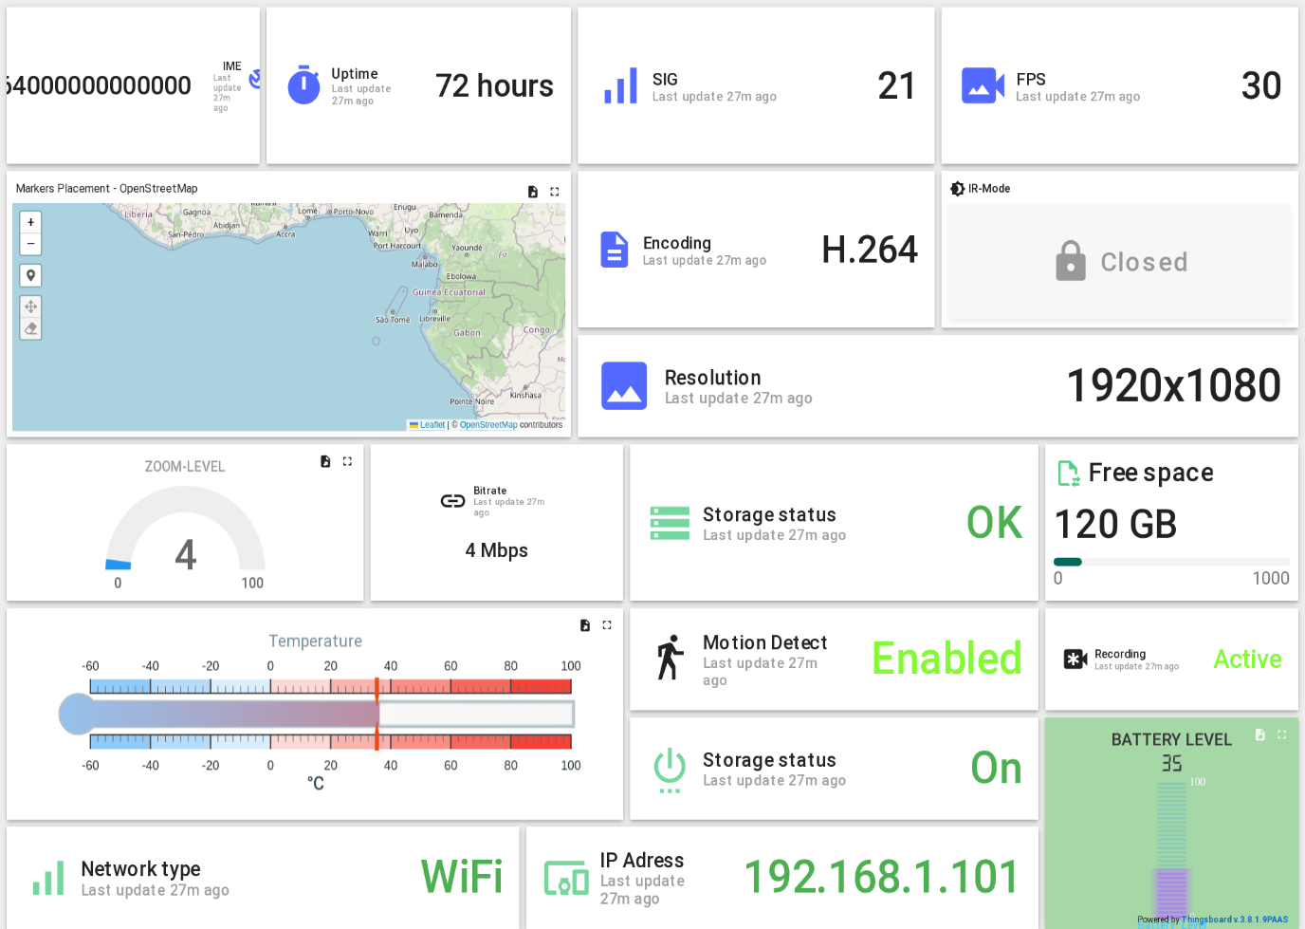

Figure 2 : Dashboard of Device Camera

## **2) Updated Device from Excel with Parameter-**

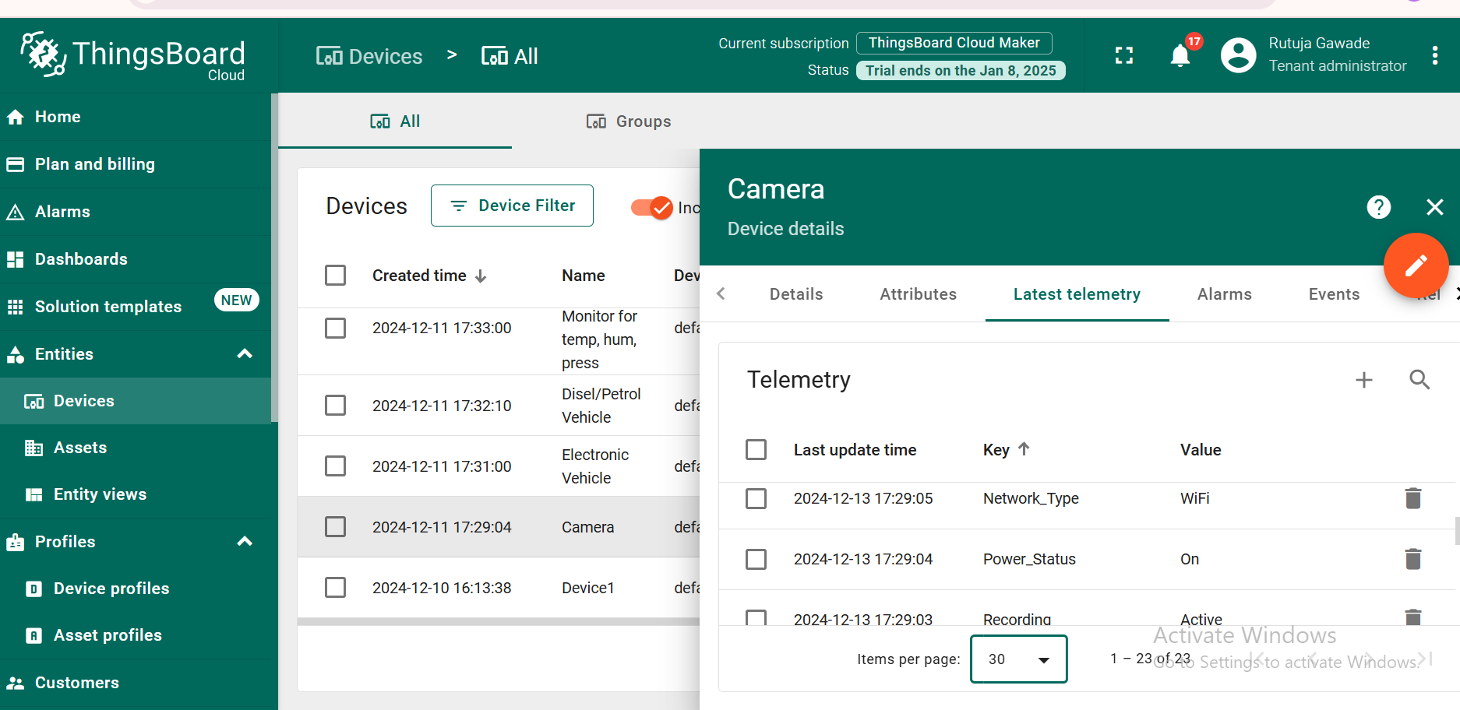

Figure 3 : Updated device with parameter from excel file

## **3) Excel File-**

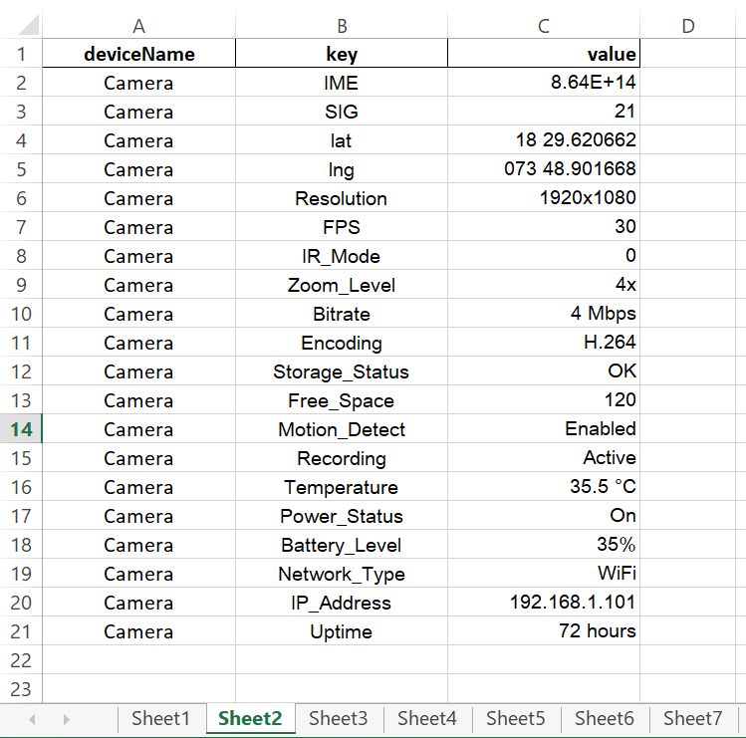

Figure 4 : Excel File

# **Logs -**

## **1) Device 1-**

Telemetry sent for device: Electronic Vehicle -> {"values":{"system_faults":"\"None\"",

"battery_level":"85","odometer":"15234","gps_longitude":"73.8567",

"tire_pressure_front_right":"32","tire_pressure_rear_left":"30",

"tire_pressure_rear_right":"30","speed":"80","motor_temperature":"75",

"ambient_temperature":"30","acceleration":"3.5","energy_consumption":"15.5",

"headlight_status":"\"On\"","tire_pressure_front_left":"32","charging_power":"11",

"charging_status":"\"Charging\"","gps_latitude":"18.5204","range_estimate":"220",

"brake_status":"\"Applied\"","regen_braking":"10"},"ts":1734498645940}

## **2) Device 2-**

Telemetry sent for device: Dam Monitoring -> {"values":{"Water Quality Index":"85",

"Dam Integrity Status":"Normal/Deformation Detected","Water Outflow":"240 m³/s",

"Pressure at Base":"5.2 MPa","Structural Strain":"0.5 mm/m","Hydraulic Head":"30 m",

"Dam Displacement":"2 mm/day","Rainfall Level":"10 mm/hour","Flood Gate Position":

"Open/Closed","Flow Rate":"200 m³/s","Reservoir Temperature":"22°C",

"Dam Wall Temperature":"18°C","Sediment Depth":"3 meters","Temperature of Water":"25°C",

"Water Inflow":"250 m³/s","Turbine Speed":"1500 RPM","Water Level":"120 m",

"Dam Vibration":"0.01 g","Reservoir pH Level":"7.5","Seismic Activity":"3.5 Richter"},"ts":1734498647106}

## **3) Device 3-**

Telemetry sent for device: Disel/Petrol Vehicle -> {"values":{"battery_voltage":"12.6",

"engine_load":"75","fuel_level":"70","odometer":"15234","engine_temperature":"90",

"vehicle_speed":"85","tire_pressure_front_right":"32","tire_pressure_rear_left":"30",

"brake_pressure":"4.5","tire_pressure_rear_right":"30","coolant_temperature":"88",

"oil_pressure":"3.2","turbo_boost_pressure":"1.5","tire_pressure_front_left":"32",

"air_intake_temperature":"30","fuel_consumption":"8.5","exhaust_temperature":"400",

"fuel_type":"\"Diesel\"","oil_temperature":"95","engine_speed":"2200"},"ts":1734498648199}

## **4) Device 4-**

Telemetry sent for device: Elevator Monitoring -> {"values":{"Elevator Position":"2.5 m

(above ground)","Battery Voltage":"12.5 V","Current Floor":"5","Door Status":"Open/Closed",

"Fault Code":"E02","Overload Weight":"850 kg","Emergency Brake Status":"Engaged/Released",

"Door Open Time":"5 s","Vibration Level":"0.2 g","Door Lock Status":"Locked/Unlocked",

"Lift Movement Direction":"Up/Down","Motor Temperature":"45°C",

"Call Button Status":"Pressed/Not Pressed","Lift Mode":"Normal/Service",

"Elevator Speed":"2 m/s","Passenger Count":"5","Power Consumption":"150 W",

"Acceleration":"0.5 m/s²","Lift Usage Time":"2 hours","Target Floor":"10"},"ts":1734498649344}

## **5) Device 5-**

Telemetry sent for device: Device1 -> {"values":{"IME":"565756","Hum":"600",

"Tco":"0038","Cur":"0014","Mod":"0002","lng":"073 48.901668","Gsp":"10.8","Dor":"0001",

"Spd":"2995","Soc":"0097","Pwm":"0065","Bfl":"low voltage","Soh":"0100","Tsn":"0257",

"Flt":"Normal","SIG":"76","Stt":"0001","Dcv":"0093","Lds":"0004","lat":"78787979"},

"ts":1734498650484}

## **6) Device 6-**

Telemetry sent for device: Camera -> {"values":{"IME":"864259068798485",

"Battery_Level":"0.85","Temperature":"35.5 °C","lng":"073 48.901668",

"Uptime":"72 hours","FPS":"30","IR_Mode":"0","Encoding":"H.264","Bitrate":"4 Mbps",

"Storage_Status":"OK","Free_Space":"120","IP_Address":"192.168.1.101","SIG":"21",

"Motion_Detect":"Enabled","Power_Status":"On","Network_Type":"WiFi","Zoom_Level":"4x",

"Recording":"Active","lat":"18 29.620662","Resolution":"1920x1080"},"ts":1734498651654}

## **7) Device 7-**

Telemetry sent for device: Weather Forecasting -> {"values":{"Max Temperature Today":"29°C",

"Temperature":"25.5°C","Dew Point":"20°C","Cloud Type":"Cumulus","Rainfall":"2 mm/h",

"Pressure Trend":"Rising","Atmospheric Pressure":"1013 hPa","Precipitation Probability":"0.4",

"Wind Direction":"120°","Solar Radiation":"450 W/m²","Cloud Cover":"0.6","Gust Speed":"25 km/h",

"Humidity":"0.78","Wind Speed":"15 km/h","Min Temperature Today":"18°C","Visibility":"10 km",

"Storm Warning":"No","UV Index":"7","Heat Index":"30°C","Wind Chill":"18°C"},"ts":1734498652772}

## **8) Device 8-**

Telemetry sent for device: Device Monitor for temp, hum, press -> {"values":{"rainfall":"0 mm",

"battery_level":"0.85","gps_longitude":"74.0060° W","pm10":"15 µg/m³","wind_direction":"45°",

"pressure":"1013 hPa","heat_index":"29.2°C","sensor_status":"Active","uv_index":"5",

"co2_concentration":"400 ppm","dew_point":"20.5°C","pm2_5":"8 µg/m³","gps_latitude":"40.7128° N",

"temperature":"25.7°C","humidity":"0.65","wind_speed":"12.5 km/h","light_intensity":"800 lux",

"air_quality_index":"48","solar_radiation":"320 W/m²","timestamp":"2024-12-10T14:30:00"},"ts":1734498653910}

## **9) Device 9-**

Telemetry sent for device: Smart Farming Device -> {"values":{"Crop Health Index":"0.85",

"Soil Temperature":"22°C","Irrigation Status":"Active","Air Humidity":"0.6",

"Rainfall":"10 mm/h","Soil Conductivity":"0.45 dS/m","Light Intensity":"500 Lux",

"Air Temperature":"30°C","Nutrient Levels":"Nitrogen: 40 ppm","Soil pH":"6.5",

"Solar Radiation":"400 W/m²","Water Level in Tank":"0.75",

"Soil Erosion Rate":"5 cm/year","Wind Speed":"18 km/h",

"Evapotranspiration":"3 mm/day","Leaf Wetness":"0.2",

"Crop Growth Stage":"Germination","Ground Temperature":"28°C",

"Fertilizer Application":"5 kg/ha","Soil Moisture":"0.45"},"ts":1734498643516}

## **10) Device 10-**

Telemetry sent for device: Automated vehicle -> {"values":{"Autopilot Mode":"Enabled",

"Driver Attention":"Active","Speed":"60 km/h","GPS Latitude":"37.7749°","Tire Pressure

(Rear Right)":"31 psi","Battery Voltage":"350 V","Steering Angle":"15°",

"Tire Pressure (Front Left)":"32 psi","GPS Longitude":"-122.4194°",

"Vehicle Temperature":"25°C","Collision Detection":"No Obstacle Detected",

"Temperature Inside":"22°C","Lane Departure Warning":"Activated","GPS Speed":"58 km/h",

"Vehicle Range":"350 km","Tire Pressure (Front Right)":"32 psi",

"Accelerator Pedal Position":"0.5","Brake Pedal Position":"0",

"Tire Pressure (Rear Left)":"31 psi","Battery Charge":"0.8"},"ts":1734498644821}

## 